**CONCLUSIONS AND RECOMMENDATIONS**

After performing the requested executions, we had to make an analysis of the results.

One thing that should be taken into account by its great importance, is that at the time of the executions a problem where the server rejects Pivotal Tracker showing many requests had the following error:

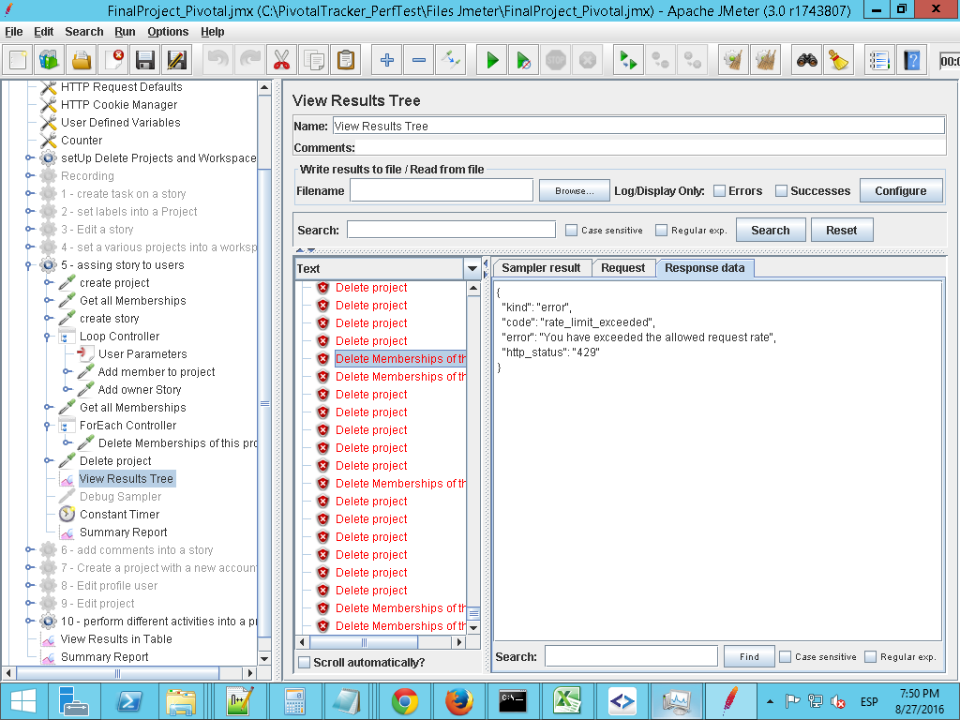

This is due to the large number of sent and applied in a short time requests.

**ANALYSIS OF RESULTS**

**Conclusion:** The graphic shows expected results, as the number of requests is rising according to increase of users

**Recommendations:** Non

**Conclusion:** Because the number of users, the response time is incremental . One result expected for this type of executions

**Recommendations:** Non

**Conclusion:** By the graph we can see that the number of bytes received is increasing according to the number of users. It is an expected result.

**Recommendations:** Non

**Conclusion**: The table shows the percentage of errors generated in different runs performed. It is a high number of errors that affect the final result

**Recommendations**: It is recommended executions where the error rate is minimum to get real results.